CHUỖI PHẢN ỨNG HỮU CƠ

Câu 1:

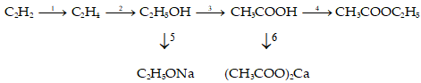

Lời giải:

Câu 2:

**Câu 3:**

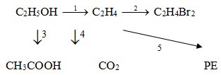

Câu 4:

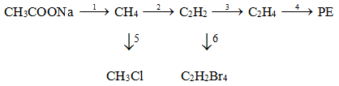

Câu 5: